

South Indian Bank

Amirtharaj R

Nov 05, 2026

—

Target vs Achievement

—

Analysis

Introduction
South Indian Bank is one of the leading private sector banks in India. It was established in 1929 and is headquartered in Thrissur, Kerala. The bank has a strong branch network across India and offers a wide range of financial services including retail banking, corporate banking, MSME loans, gold loans, CASA products, and digital banking services. The bank focuses on sustainable growth, customer satisfaction, digital transformation, and strong asset quality management.



Objective of the study

The primary objective of this project is to conduct a comprehensive performance analysis of South Indian Bank by systematically evaluating the relationship between business targets and actual achievements across various Regional Offices (RO Level). The study aims to measure operational efficiency, productivity levels, and goal attainment across different banking segments.

This analysis seeks to:

Assess Target Achievement Efficiency:
To evaluate how effectively each Regional Office has achieved its assigned business targets and to measure the percentage of achievement across multiple banking products.

Identify High and Low Performing Regions:
To classify Regional Offices based on their performance levels and identify top-performing regions that demonstrate strong execution strategies, as well as underperforming regions that require strategic improvement and corrective action.

Analyze Growth Trends (MTD & YTD):
To examine both Month-to-Date (MTD) and Year-to-Date (YTD) growth patterns in order to understand short-term momentum and long-term sustainability of business expansion.

Measure Overall Business Gap:
To calculate the difference between total targets and total achievements across all regions and determine the magnitude of the performance gap. This helps in understanding whether the bank is on track to meet its strategic goals.

Evaluate Product-Level Performance (Gold Loan Focus):
To analyze the performance of key revenue-generating products such as Gold Loans by comparing target allocation and actual disbursement performance, thereby assessing product demand and profitability contribution.

Examine Asset Quality through SMA Reduction:
To evaluate the effectiveness of recovery mechanisms by analyzing SMA (Special Mention Account) reduction percentages across Regional Offices. This helps in understanding credit monitoring efficiency and asset quality management.

Support Strategic Decision-Making:
To provide data-driven insights that can assist management in making informed strategic decisions, improving business planning, optimizing resource allocation, and strengthening regional performance monitoring.

Overall, this study aims to provide a structured, analytical, and performance-driven evaluation framework that helps in understanding both growth potential and operational challenges within South Indian Bank.

Data Source and Tools Used
The data used for this analysis is internal business performance data of South Indian Bank. Microsoft Excel was used for data cleaning and preparation. Power BI was used for creating dashboards, charts, and visual representations for better analysis and interpretation
The following activities were performed using Excel:
Data Cleaning: Removing duplicate records, correcting spelling errors, and ensuring consistent formatting of data fields.
Data Structuring: Arranging the data into proper columns and rows such as Region Name, Target, Achievement, MTD Growth, YTD Growth, Gold Loan Performance, and SMA Reduction.
Data Validation: Checking for missing values and correcting inaccurate entries to maintain data accuracy.
Basic Calculations: Performing simple calculations such as totals and percentages where necessary.
Formatting: Preparing the dataset in a tabular format so that it can be easily imported into Power BI for further analysis.

The following tasks were performed using Power BI:
Data Import: Importing the cleaned Excel dataset into Power BI.
Data Modeling: Establishing relationships between different data fields to support effective analysis.
Creating Measures and Calculations: Calculating achievement percentages, growth rates, and performance gaps.
Visualization: Creating charts such as bar charts, column charts, and KPI visuals to represent regional performance clearly.
Dashboard Development: Designing a dashboard that allows users to easily understand business performance across regions.
Performance Analysis: Identifying top-performing regions, low-performing regions, target gaps, and growth trends using visual insights.

Insights
Regional Level Target vs Achievement Analysis
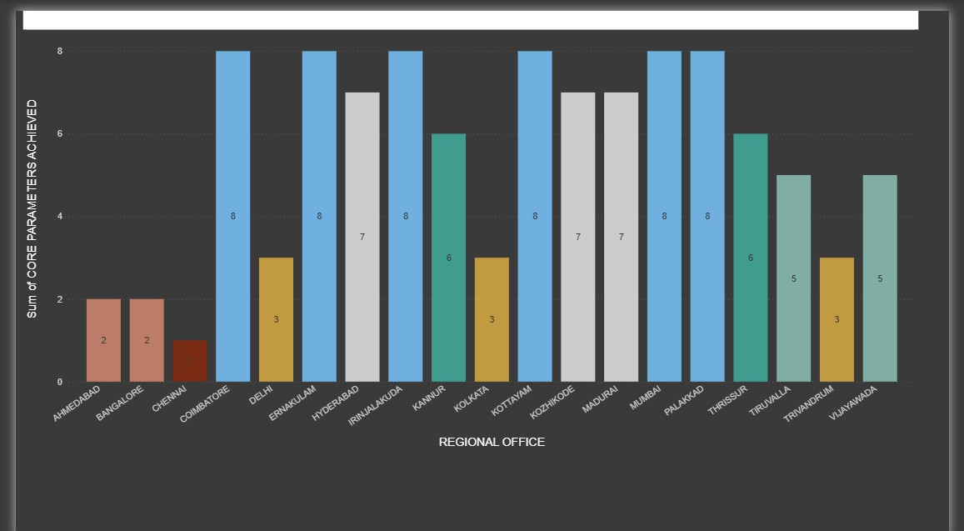
The regional level analysis compares the target and achievement values for different Regional Offices. The comparison helps to identify which regions have achieved their targets and which regions are lagging behind. Some regions have performed close to their targets, showing effective planning and execution. However, certain regions show a gap between target and achievement, indicating the need for improved business strategies and monitoring.

Core Business Performance – RO Level
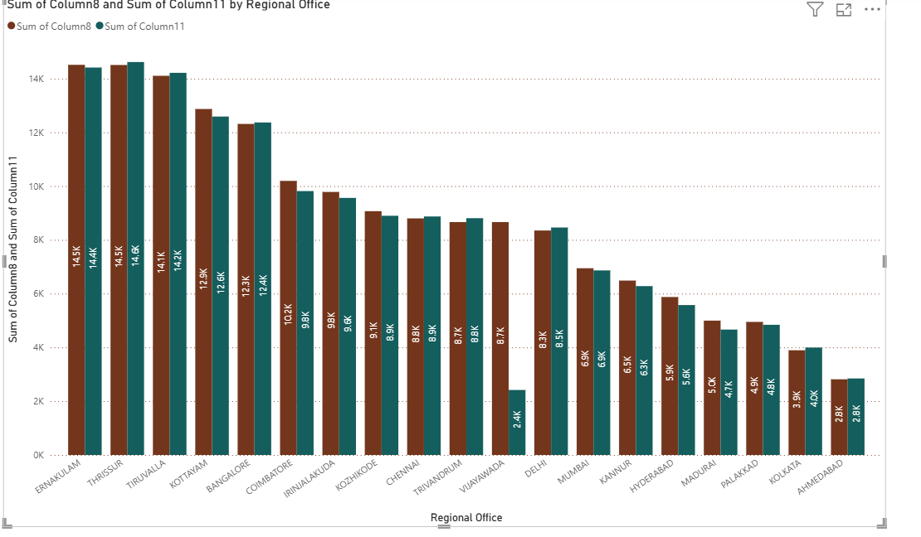
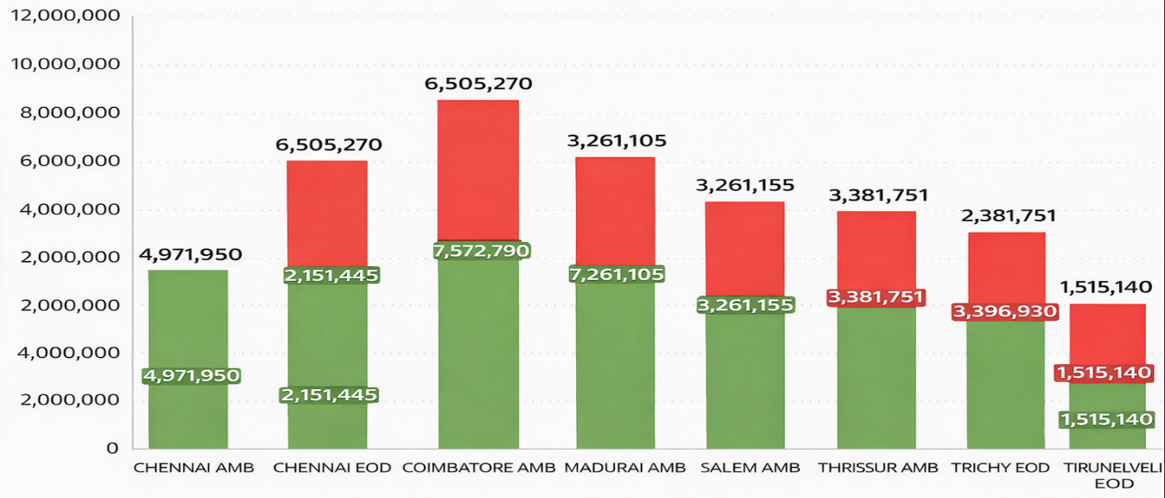

The core business performance analysis compares the target and achievement levels of major banking products across different Regional Offices. From the chart, regions such as Ernakulam, Thrissur, Tiruvalla, and Coimbatore show strong performance with achievement values very close to their targets. This indicates effective business planning, strong customer relationships, and good sales performance in these regions. Regions like Kottayam, Bangalore, and Kozhikode also show stable performance with moderate gaps between target and achievement, suggesting consistent business growth and balanced operational performance.
However, some regions such as Vijayawada, Hyderabad, Madurai, Palakkad, Kolkata, and Ahmedabad show comparatively lower achievement levels when compared to their targets. The noticeable gap indicates the need for improved business strategies, stronger marketing efforts, and better customer engagement to increase product penetration and business volume. By focusing on these low-performing regions and implementing targeted sales initiatives, the bank can improve overall performance and achieve balanced regional business growth.

Overall Achievement Percentage – RO Level
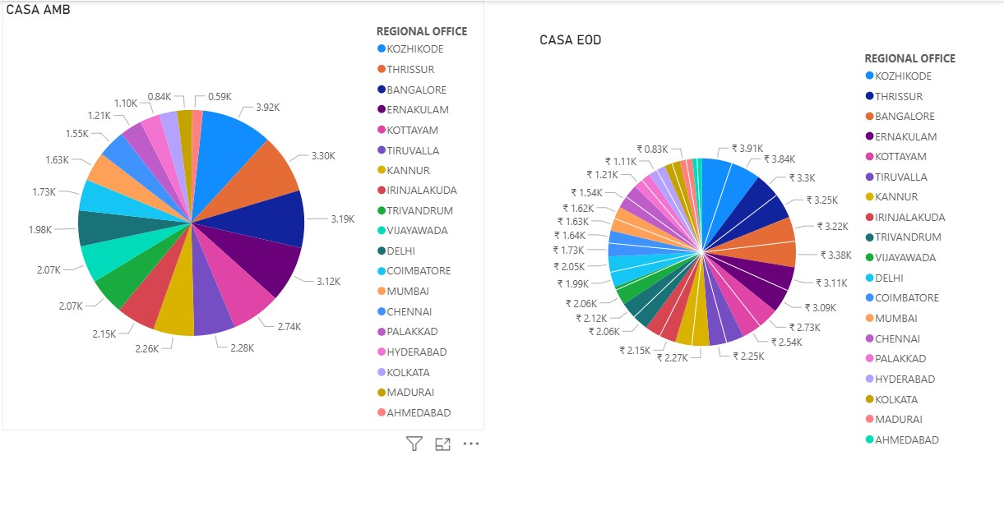

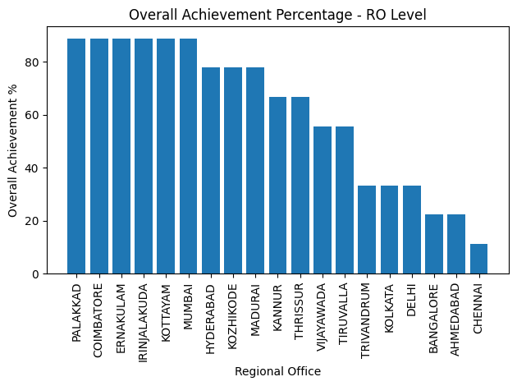

The Overall Achievement Percentage at the Regional Office (RO) level provides a clear understanding of how effectively each region has achieved its assigned business targets. From the chart, regions such as Palakkad, Coimbatore, Ernakulam, Irinjalakuda, Kottayam, and Mumbai have achieved more than 80% of their targets, indicating strong business performance and effective execution of sales strategies. These regions demonstrate efficient management, strong customer engagement, and successful promotion of banking products, which contributes significantly to the overall growth of the bank. Their high achievement percentages indicate that the targets were well planned and properly monitored throughout the period.
On the other hand, some regions such as Vijayawada, Tiruvalla, Trivandrum, Kolkata, Delhi, Bangalore, Ahmedabad, and Chennai show comparatively lower achievement percentages. In particular, Chennai and Ahmedabad record the lowest performance levels, highlighting a significant gap between the targets and actual achievements. This suggests that these regions may be facing challenges such as lower customer acquisition, limited product penetration, or operational constraints. To improve performance in these areas, the bank may need to implement stronger marketing initiatives, improve customer relationship management, and focus on targeted business development strategies to increase overall achievement levels across all regions.

Top 10 MTD Growth Branches
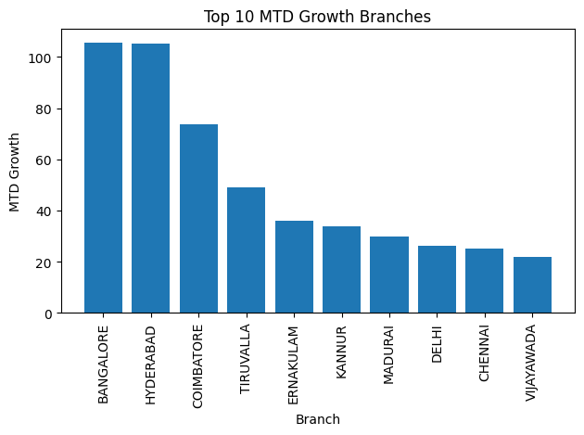
The Month-to-Date (MTD) growth analysis identifies branches that have shown significant growth within the current month. Branches such as Bangalore and Hyderabad demonstrate strong short-term business momentum. This indicates effective sales strategies and active business acquisition in the current period.

Top 10 YTD Growth Branches
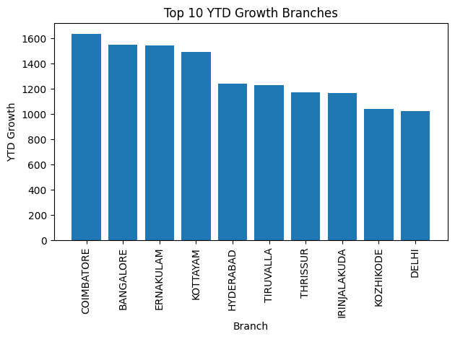
The Year-to-Date (YTD) growth analysis highlights branches that have consistently performed well throughout the year. Regions such as Coimbatore and Bangalore show strong cumulative growth. This reflects sustainable business expansion and consistent performance over a longer period.

Total Gap Analysis
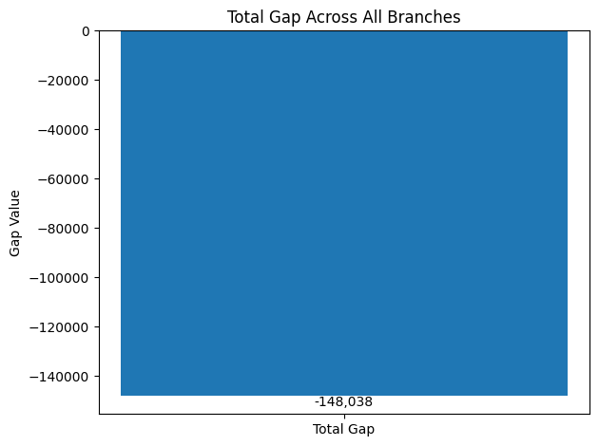
The total gap analysis measures the difference between overall target and total achievement across all branches. The analysis indicates that there is a measurable gap between expected and actual performance. By focusing on underperforming regions and strengthening monitoring mechanisms, this gap can be reduced effectively.

Gold Loan Target vs Achievement
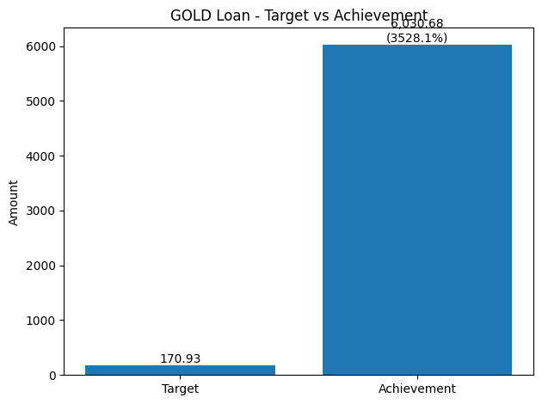
The Gold Loan Target vs Achievement analysis shows a very strong performance in the gold loan segment. According to the chart, the target for gold loans is about 170.93, while the actual achievement has reached approximately 6030.68, which is significantly higher than the assigned target. This indicates that the demand for gold loans is extremely high and the bank has performed exceptionally well in this product segment. Gold loans are popular among customers because they provide quick access to funds with minimal documentation and faster processing. The large gap between the target and achievement highlights the importance of gold loans as a major contributor to the bank’s business growth and revenue, and it suggests that the bank can further strengthen this segment by setting higher targets and expanding gold loan services in the future.

SMA Reduction Performance – RO Level
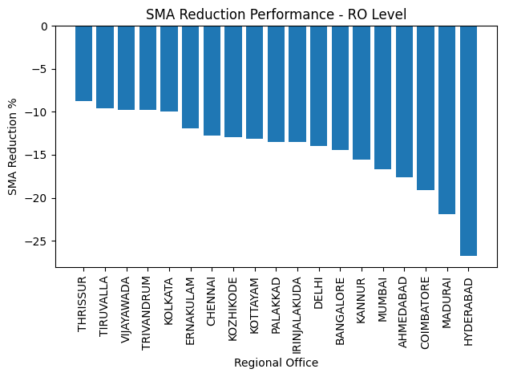
The SMA (Special Mention Account) Reduction Performance at the Regional Office level shows how effectively different regions have managed to reduce stressed or potentially risky loan accounts. From the chart, most regions demonstrate a negative SMA reduction percentage, which indicates a positive outcome because it means that the number of stressed accounts has decreased. Regions such as Thrissur, Tiruvalla, Vijayawada, Trivandrum, and Kolkata show moderate reductions, reflecting consistent monitoring and recovery efforts. On the other hand, regions like Hyderabad, Madurai, and Coimbatore show the highest level of SMA reduction, indicating strong recovery performance and effective credit monitoring systems in place. This reduction in SMA accounts helps improve the bank’s asset quality, reduces credit risk, and strengthens overall financial stability. The performance also highlights the importance of proactive loan monitoring, timely follow-ups with borrowers, and effective recovery strategies to control non-performing assets and maintain a healthy loan portfolio.

Bank – Level Financial Performance FY 2025-26
Financial indicator | FY 2025–26
Net profit (₹ crore) | 1,455.14
Operating profit (₹ crore) | 2,373.37
Net profit growth | 11.69%
Total gross business (₹ crore) | 2,23,620.37
Source: South Indian Bank press release on audited results for the year ended 31 March 2026, published on 6 May 2026.

Rank | Regional Office | Total Business (13-Feb-2026) | RO Profit Contribution Percentage
1 | ERNAKULAM | 14,511.87 | 8.65%
2 | THRISSUR | 14,505.71 | 8.64%
3 | TIRUVALLA | 14,103.32 | 8.41%
4 | KOTTAYAM | 12,868.73 | 7.67%
5 | BANGALORE | 12,312.90 | 7.34%
6 | COIMBATORE | 10,194.75 | 6.08%
7 | IRINJALAKUDA | 9,783.91 | 5.83%
8 | KOZHIKODE | 9,068.59 | 5.40%
9 | CHENNAI | 8,799.97 | 5.24%
10 | VIJAYAWADA | 8,663.30 | 5.16%
11 | TRIVANDRUM | 8,663.30 | 5.16%
12 | DELHI | 8,349.40 | 4.98%
13 | MUMBAI | 6,945.93 | 4.14%
14 | KANNUR | 6,487.18 | 3.87%
15 | HYDERABAD | 5,876.32 | 3.50%
16 | MADURAI | 4,997.80 | 2.98%
17 | PALAKKAD | 4,949.81 | 2.95%
18 | KOLKATA | 3,895.31 | 2.32%
19 | AHMEDABAD | 2,816.05 | 1.68%
Bank – Regional Business Position FY 2025-26

Key Findings
- Ernakulam ranked first with 14,511.87, representing 8.65% of the combined business value of the 19 Regional Offices.
- Thrissur ranked second with 14,505.71 (8.64%), followed by Tiruvalla with 14,103.32 (8.41%).
- Coimbatore recorded the highest YTD increase in the workbook (1,636.79), followed by Bangalore (1,549.55) and Ernakulam (1,544.84). YTD increase indicates business growth and is not a measure of net profit.

Conclusion
The analysis of the business performance data of South Indian Bank using Excel and Power BI provides valuable insights into the performance of different Regional Offices across various banking parameters. The comparison of regional targets and achievements shows that regions such as Ernakulam, Thrissur, Tiruvalla, and Coimbatore have performed strongly and achieved business values close to their targets. These regions demonstrate effective business planning, strong customer relationships, and successful implementation of sales strategies. The core business parameter analysis also indicates that several regions have successfully achieved most of their key performance indicators, reflecting stable operational performance and strong product penetration.
The Overall Achievement Percentage analysis further highlights that regions like Palakkad, Coimbatore, Ernakulam, Irinjalakuda, Kottayam, and Mumbai have achieved more than 80% of their targets, indicating strong execution and effective monitoring. At the same time, some regions such as Chennai, Ahmedabad, Bangalore, and Delhi show lower achievement percentages, suggesting that additional efforts are required to improve performance. The MTD and YTD growth analysis identifies branches such as Bangalore, Hyderabad, Coimbatore, and Ernakulam as major contributors to business growth, reflecting strong month-to-date and year-to-date performance trends.
The analysis also shows that there is a total business gap of approximately 148,038, indicating the difference between overall targets and achievements across branches. However, the Gold Loan segment has performed exceptionally well, with the achievement significantly exceeding the target, highlighting strong customer demand and making it one of the key revenue-generating products for the bank. In addition, the SMA reduction performance shows that many regions have successfully reduced stressed accounts, which improves the bank’s asset quality and reduces credit risk.
Overall, the findings indicate that while several regions demonstrate strong performance and contribute positively to business growth, certain regions still require improved strategies, stronger sales initiatives, and better customer engagement. By focusing on low-performing regions, strengthening product promotion, and continuing effective monitoring of loan portfolios, the bank can enhance its overall performance, reduce business gaps, and achieve balanced growth across all Regional Offices.

